**Introduction and Purpose**

After successfully completing the classification between fruits (apple and tomato) and between ripeness differences, the AI model is ready to send commands back to iot devices to control an actuator or printing out to the screen.

**Implementation**

The implementation in this project will include the sending of classification results to an MQTT broker. After that, the device in this case will proceed to take the command from MQTT broker to present to the screen the information retrieved from MQTT broker by showing to the screen.

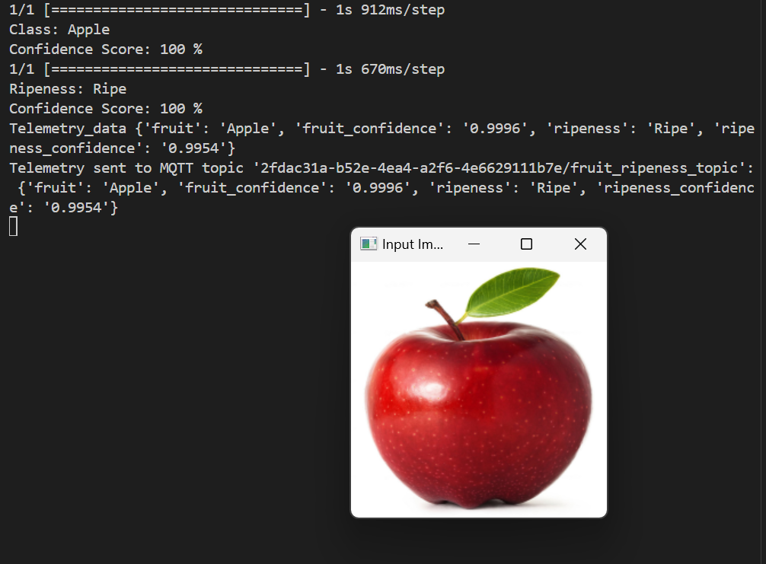

=> Image successfully classified and sent to MQTT topic with content of the type of fruit, ripeness and confident score.

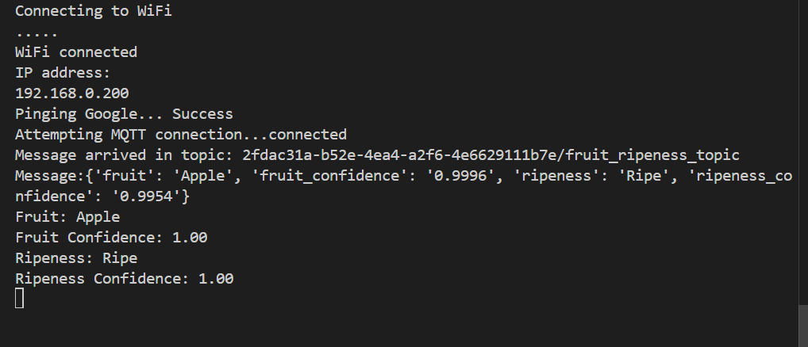

===> Information about the prediction of fruit and ripeness level is successfully published and retrieved by ESP32

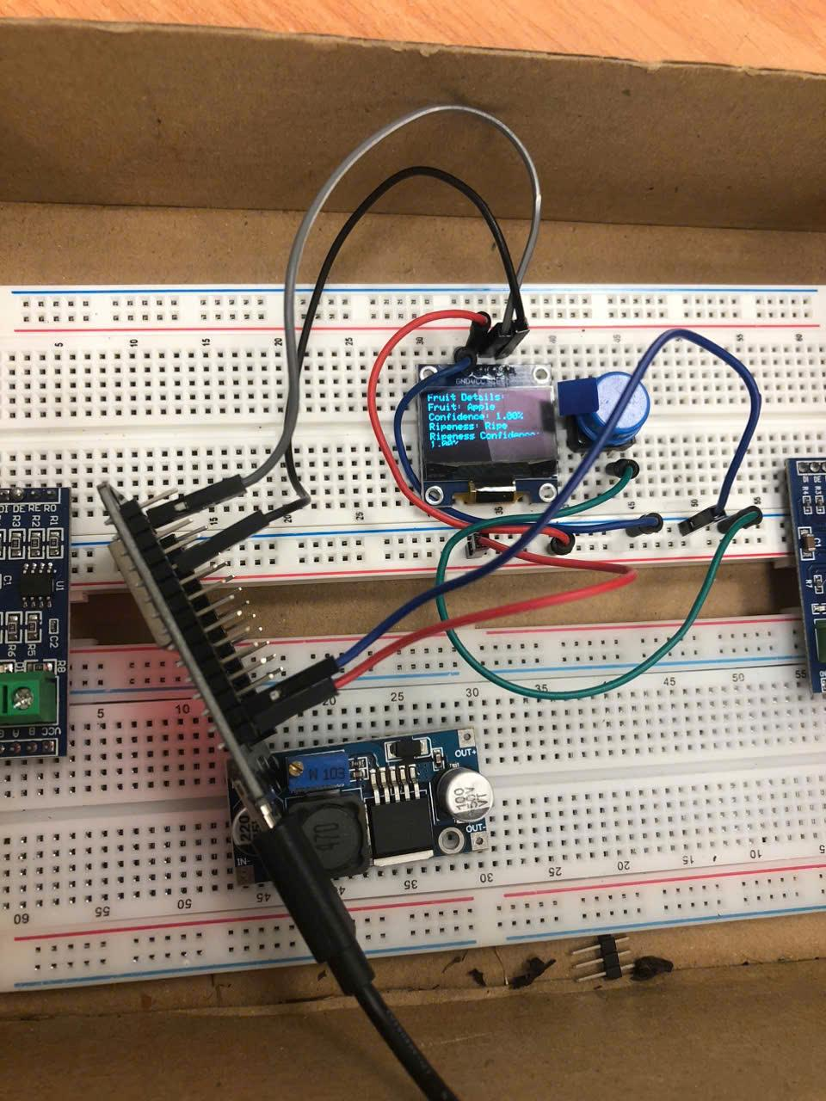 ===> The Data is then display through adafruit lcd1306 screen, projecting the **fruit name, confidence score, ripeness and confidence score.**